S3 task
1. Create an S3 bucket and upload some objects to S3.
• Login to AWS Console
• Search → S3
• Created new bucket name my-bucket-ricky5
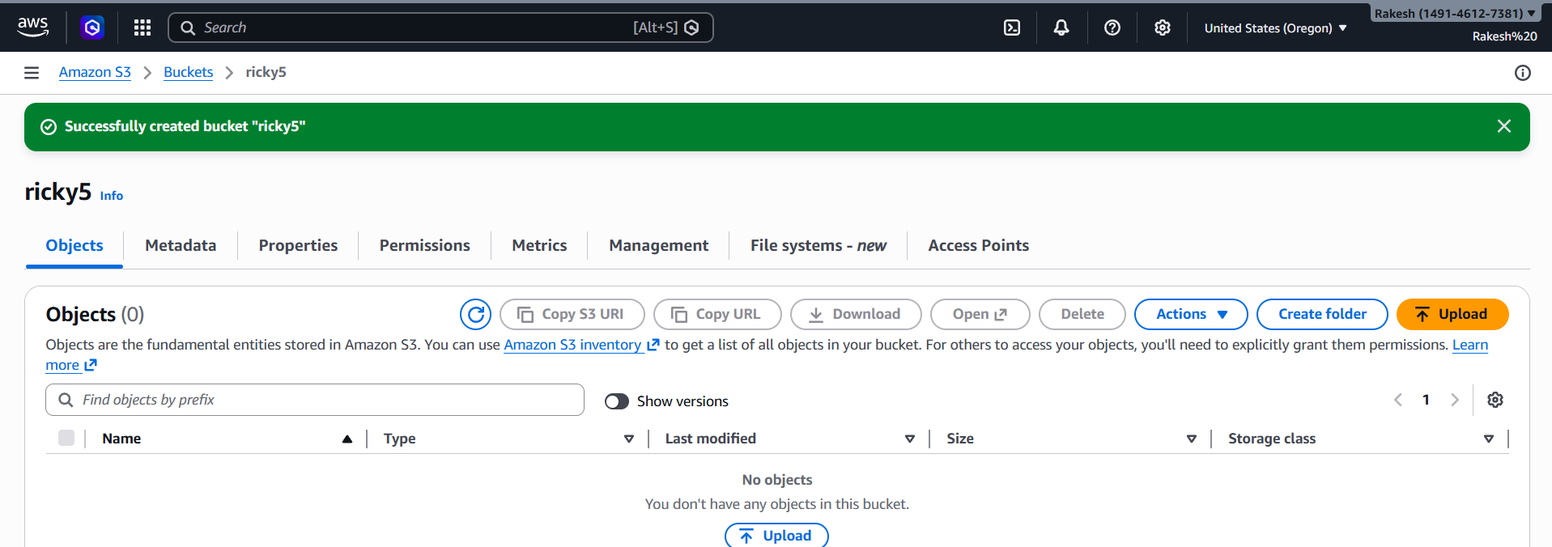
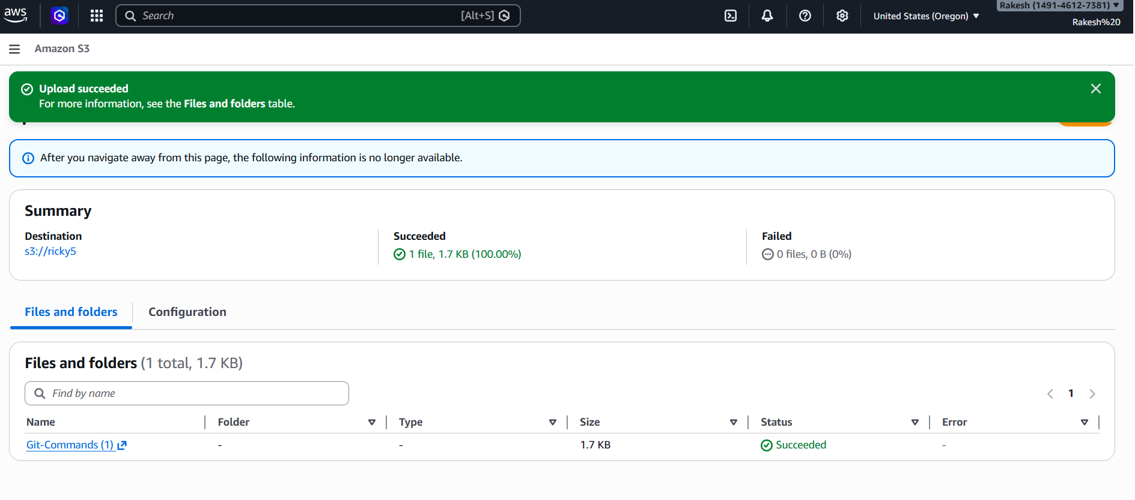
2. Deploy a static website in the S3 bucket.

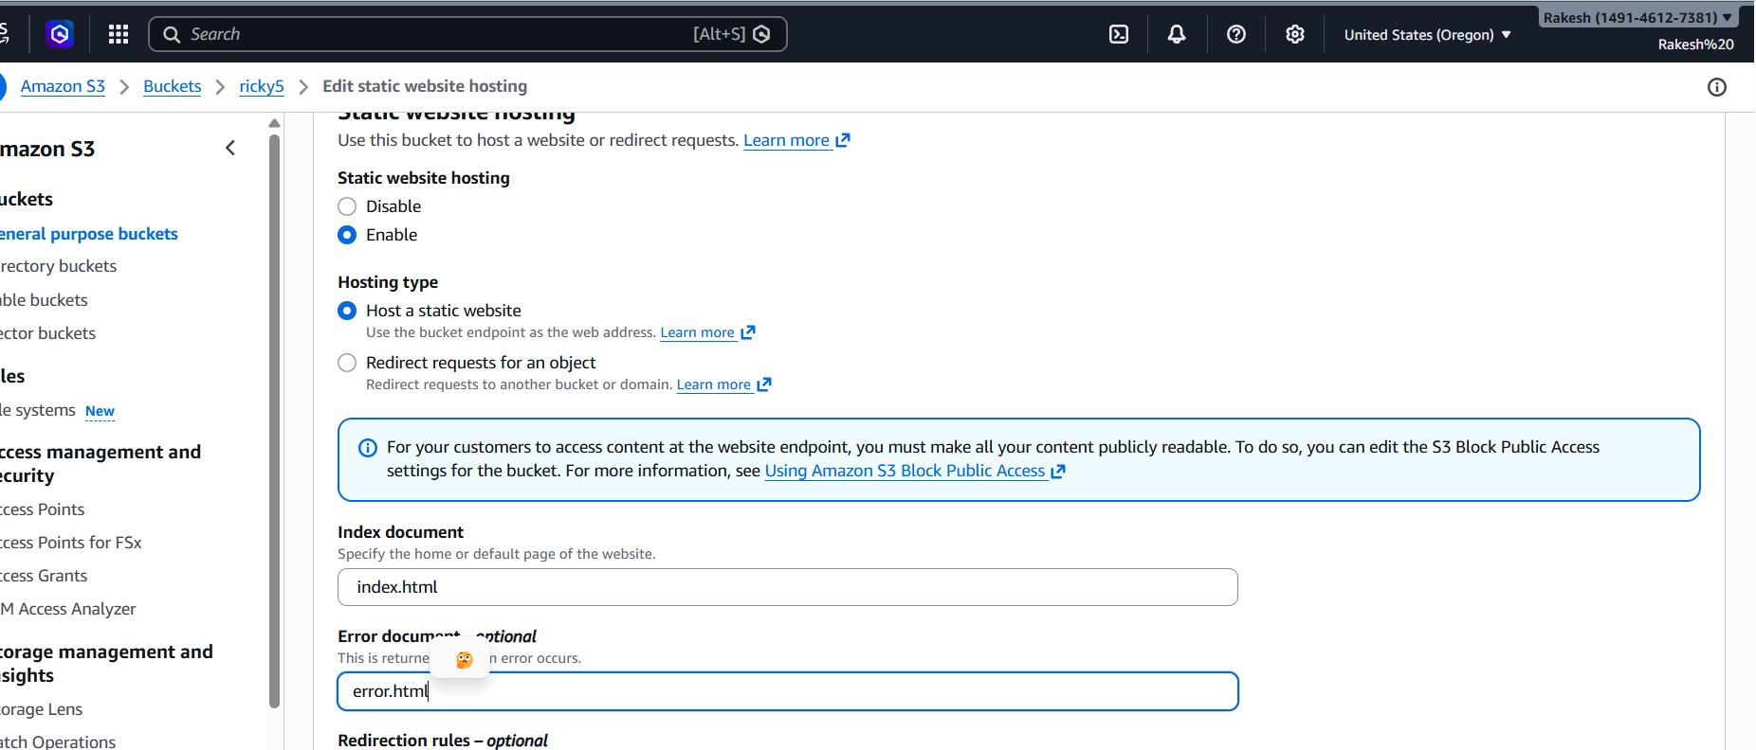

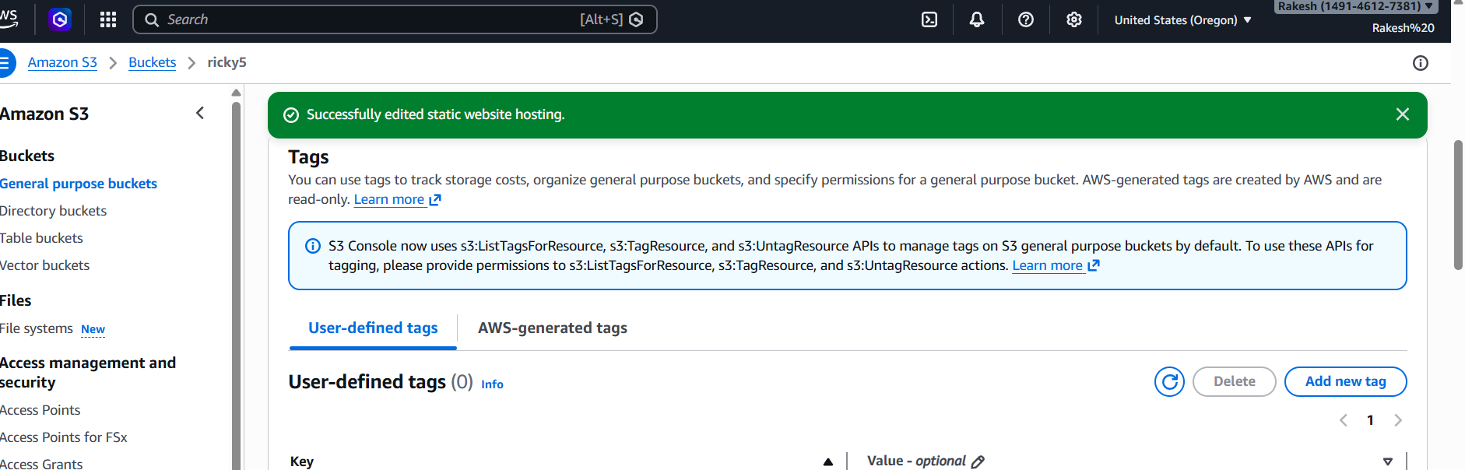

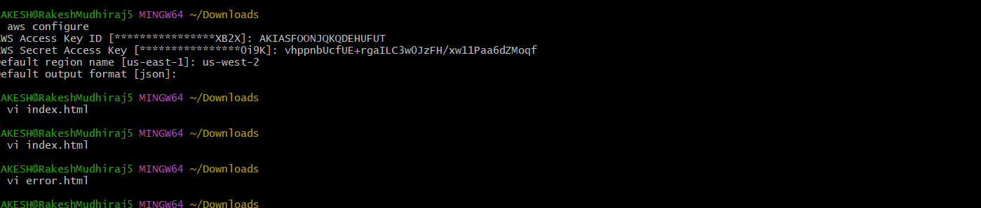
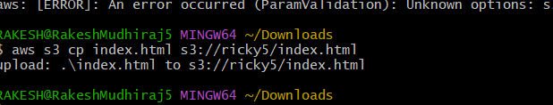
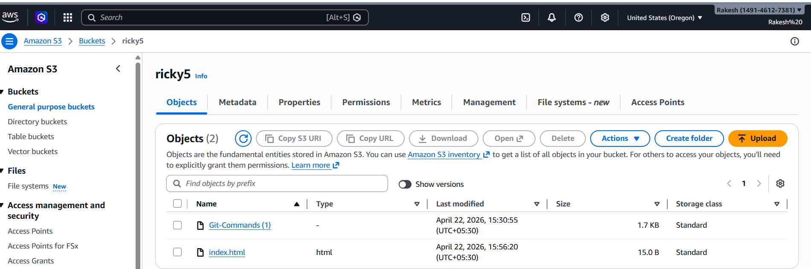
• Successfully we can see the output
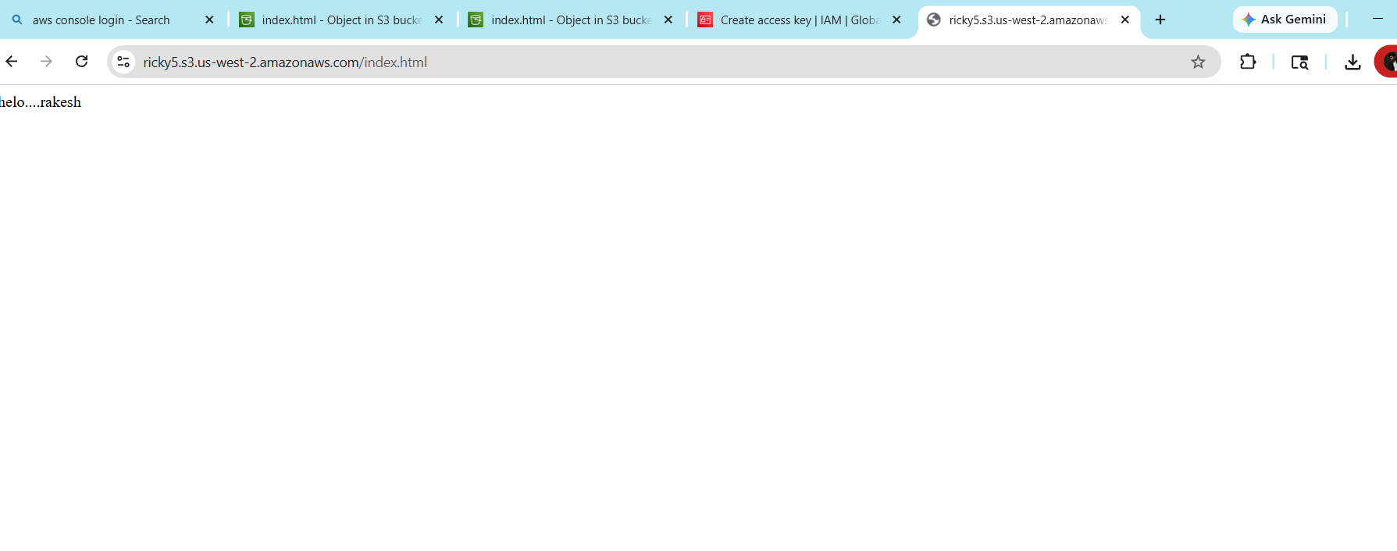
3. Enable cross-region replication on S3 buckets.

Create Two Buckets in different regions
> Enable Versioning
> Permissions: Uncheck “Block all public access
Acknowledge warning
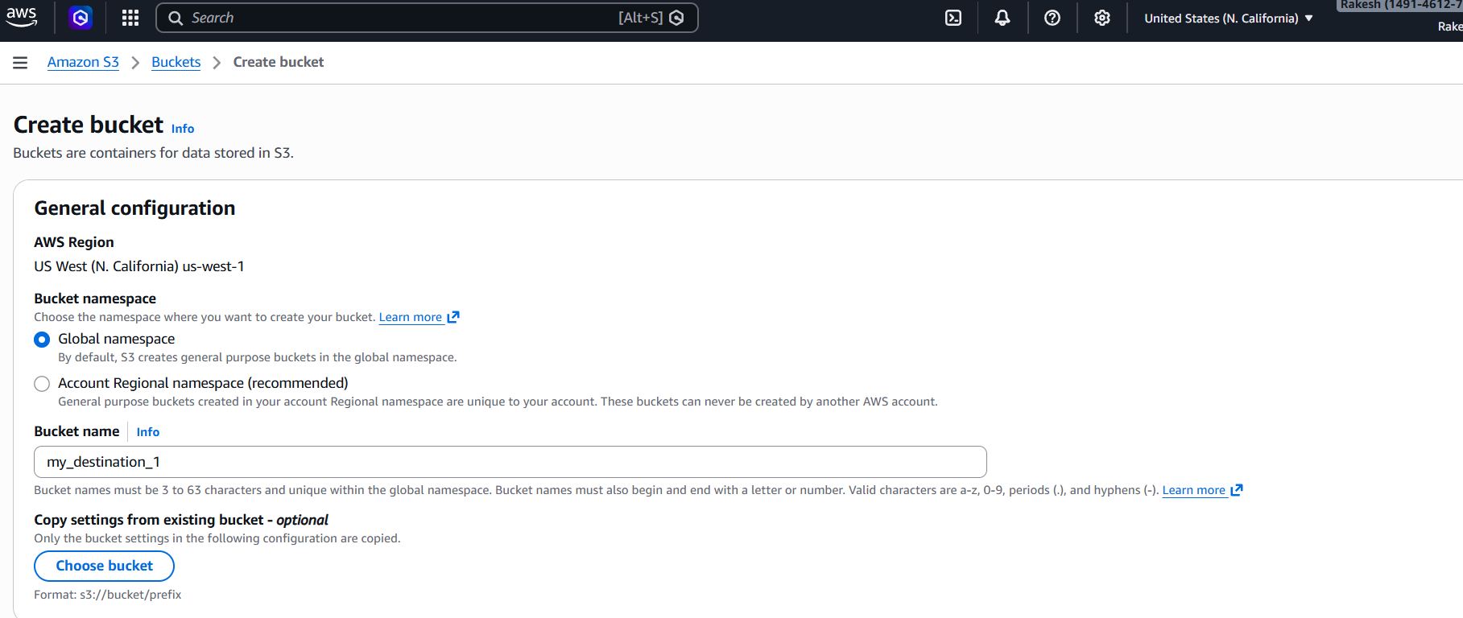
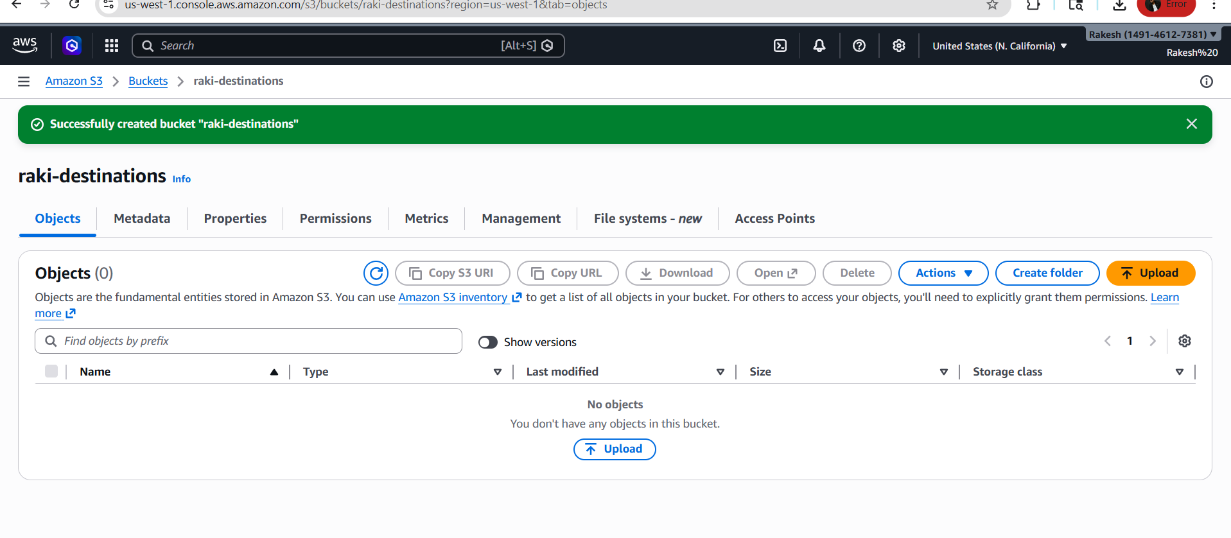
Click Management >>Scroll to Replication rules >> Click Create
replication rule
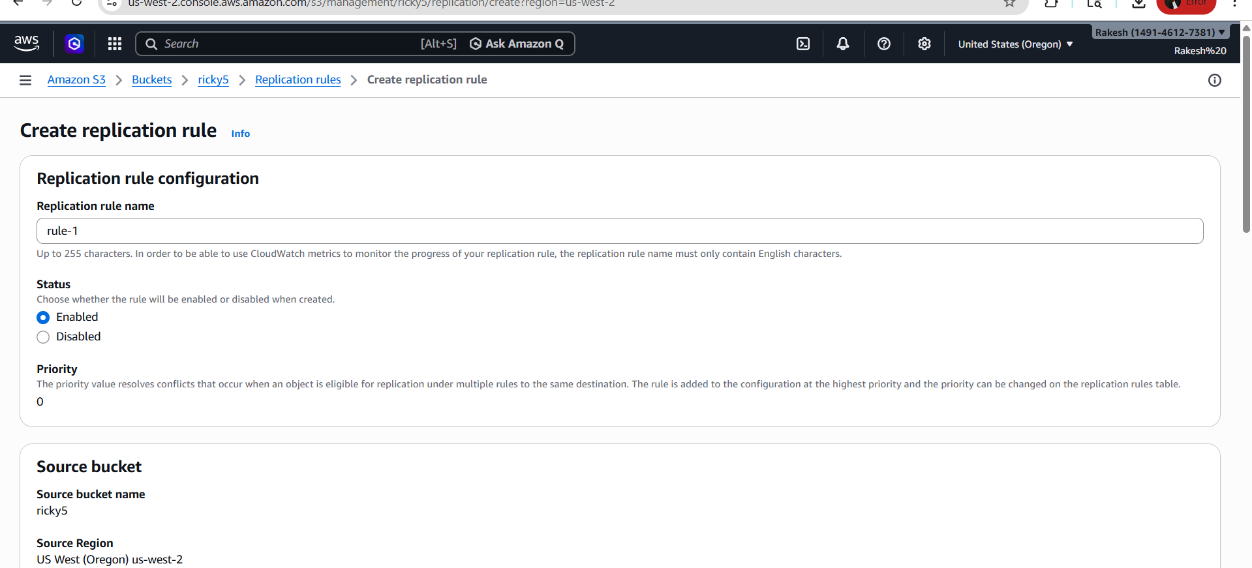
Destination bucket → select your destination bucket >>Region will auto-select
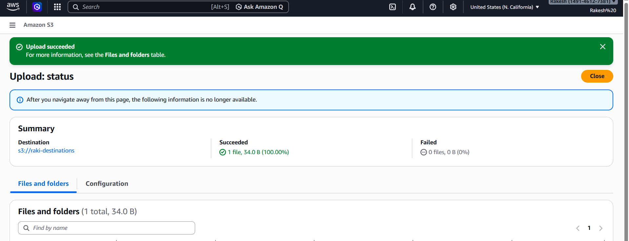
I have Upload a file to source bucket >>Wait few seconds >>Check destination bucket

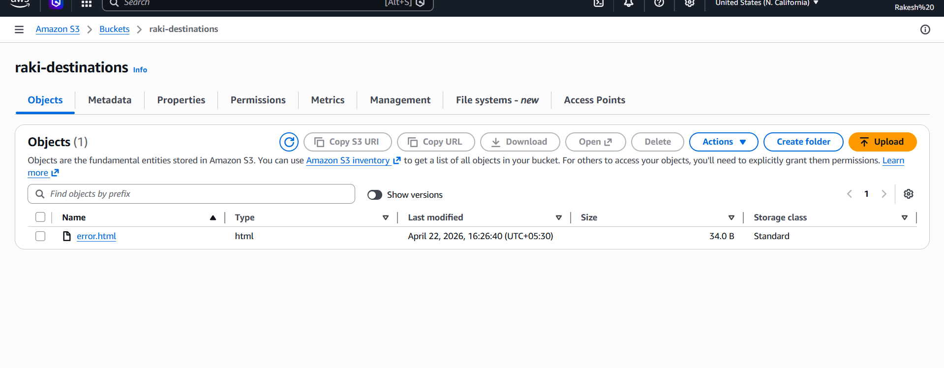
4) Configure a bucket policy so only the Admin user can see the objects of the S3 bucket.
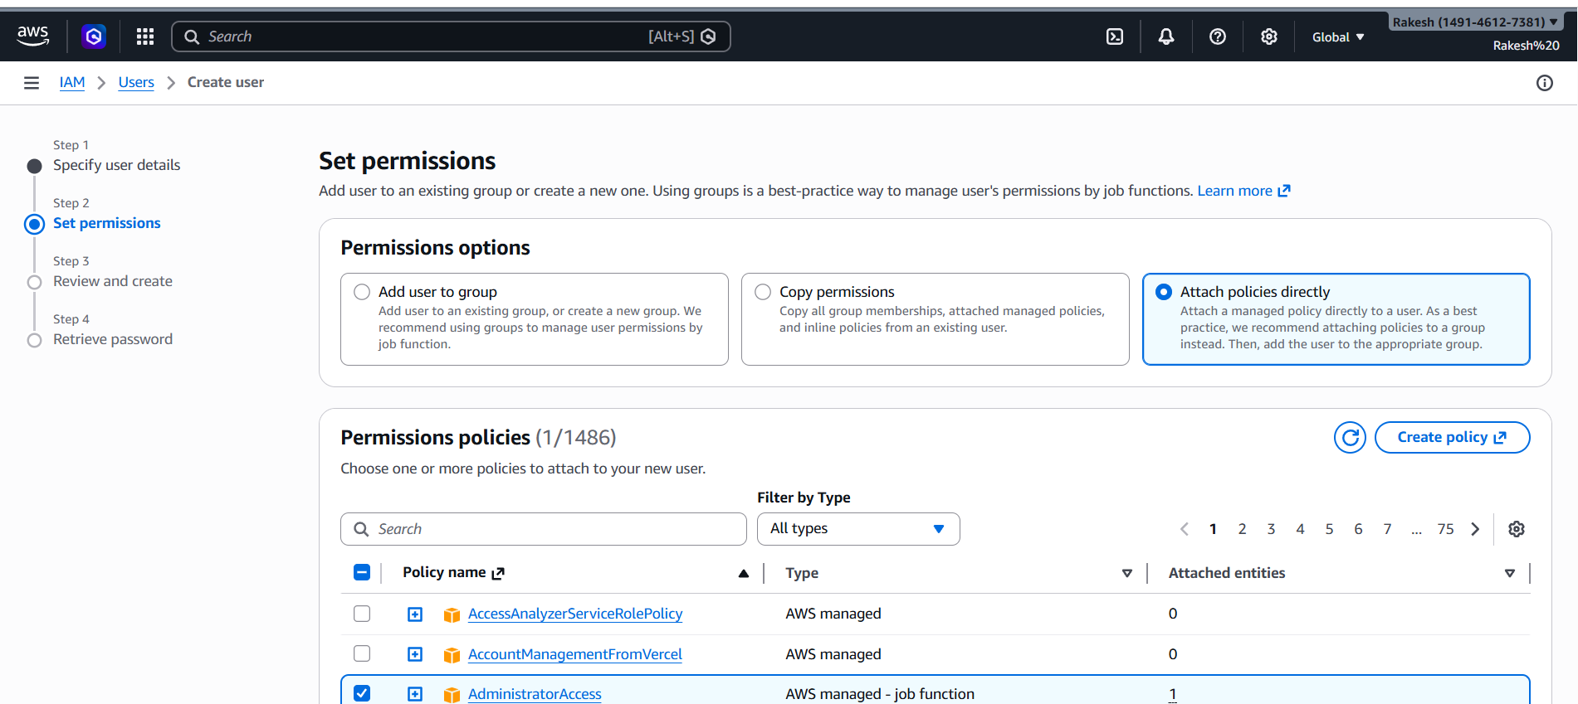
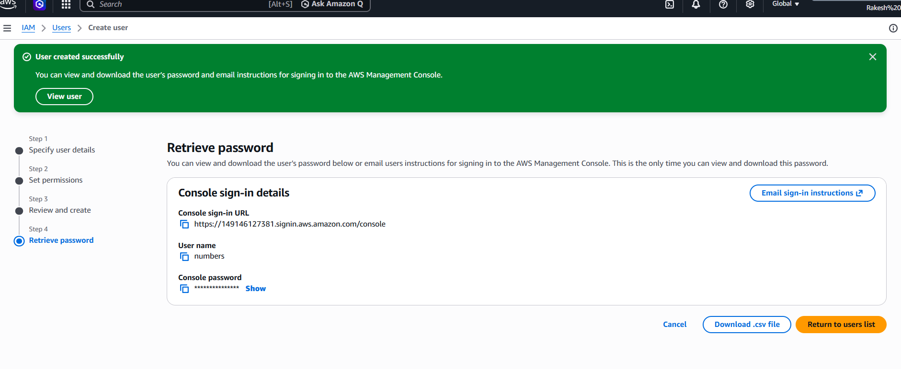
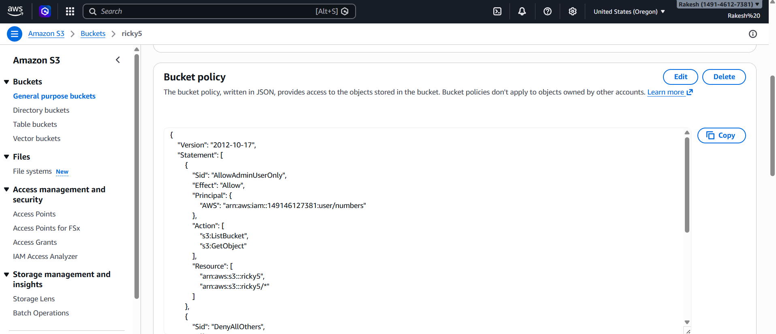
I have added bucket policy by adding user and bucket name

----I tried to access bucket with admin, it worked successfully
----When I tried to access with another user it denied
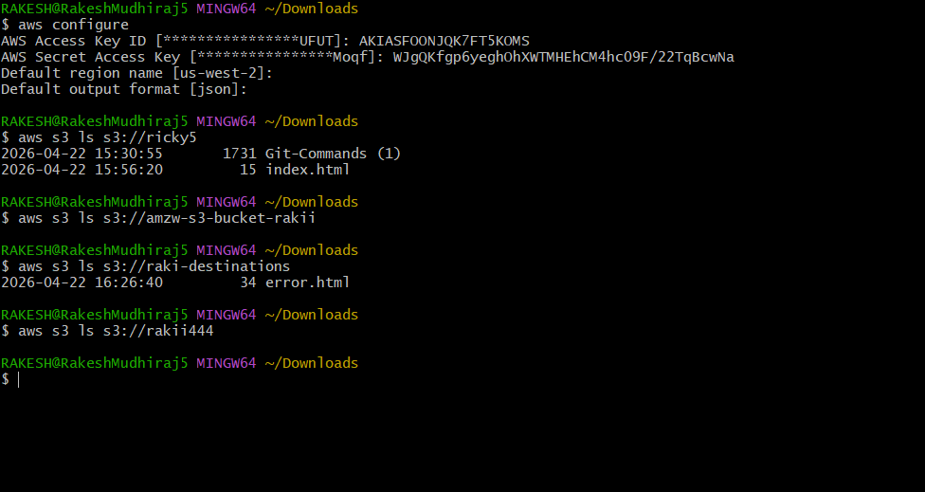
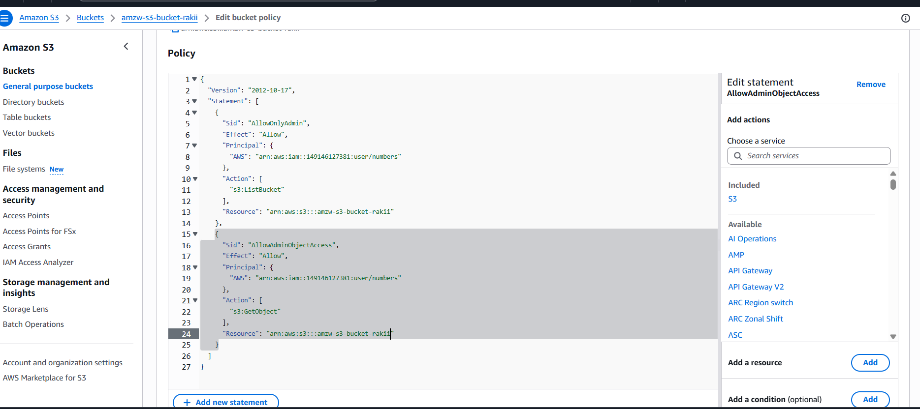

5. Set up lifecycle policies to automatically transition or delete objects based on specific criteria
First go to s3 bucket>>click management >>click on create lifecycle
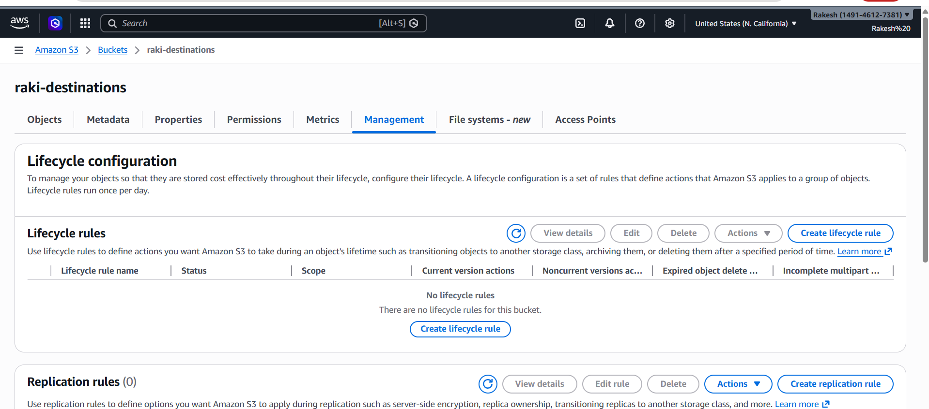

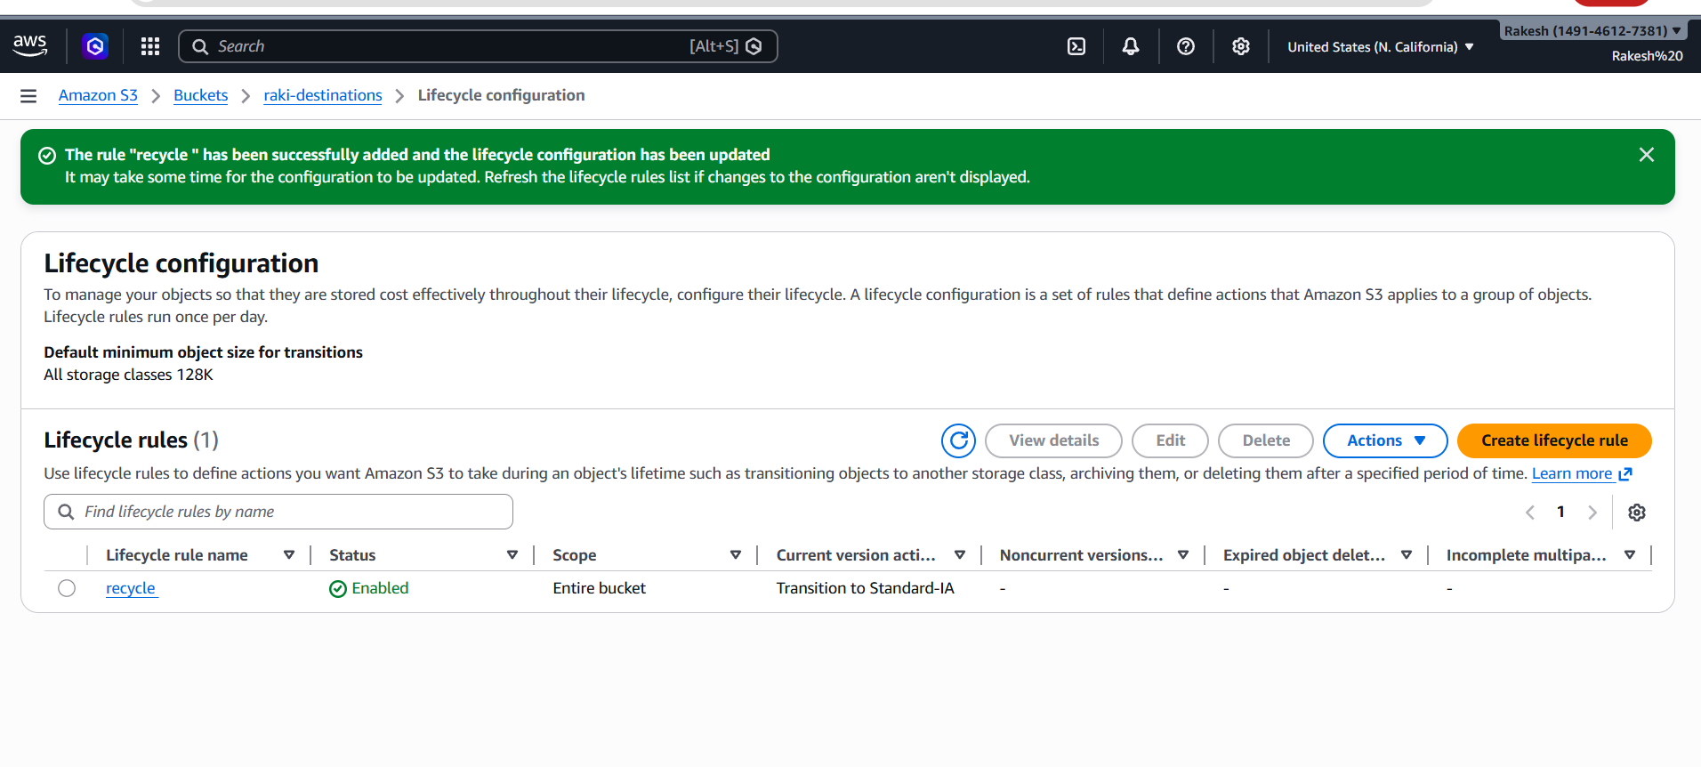
I have verified by checking lifecycle rule
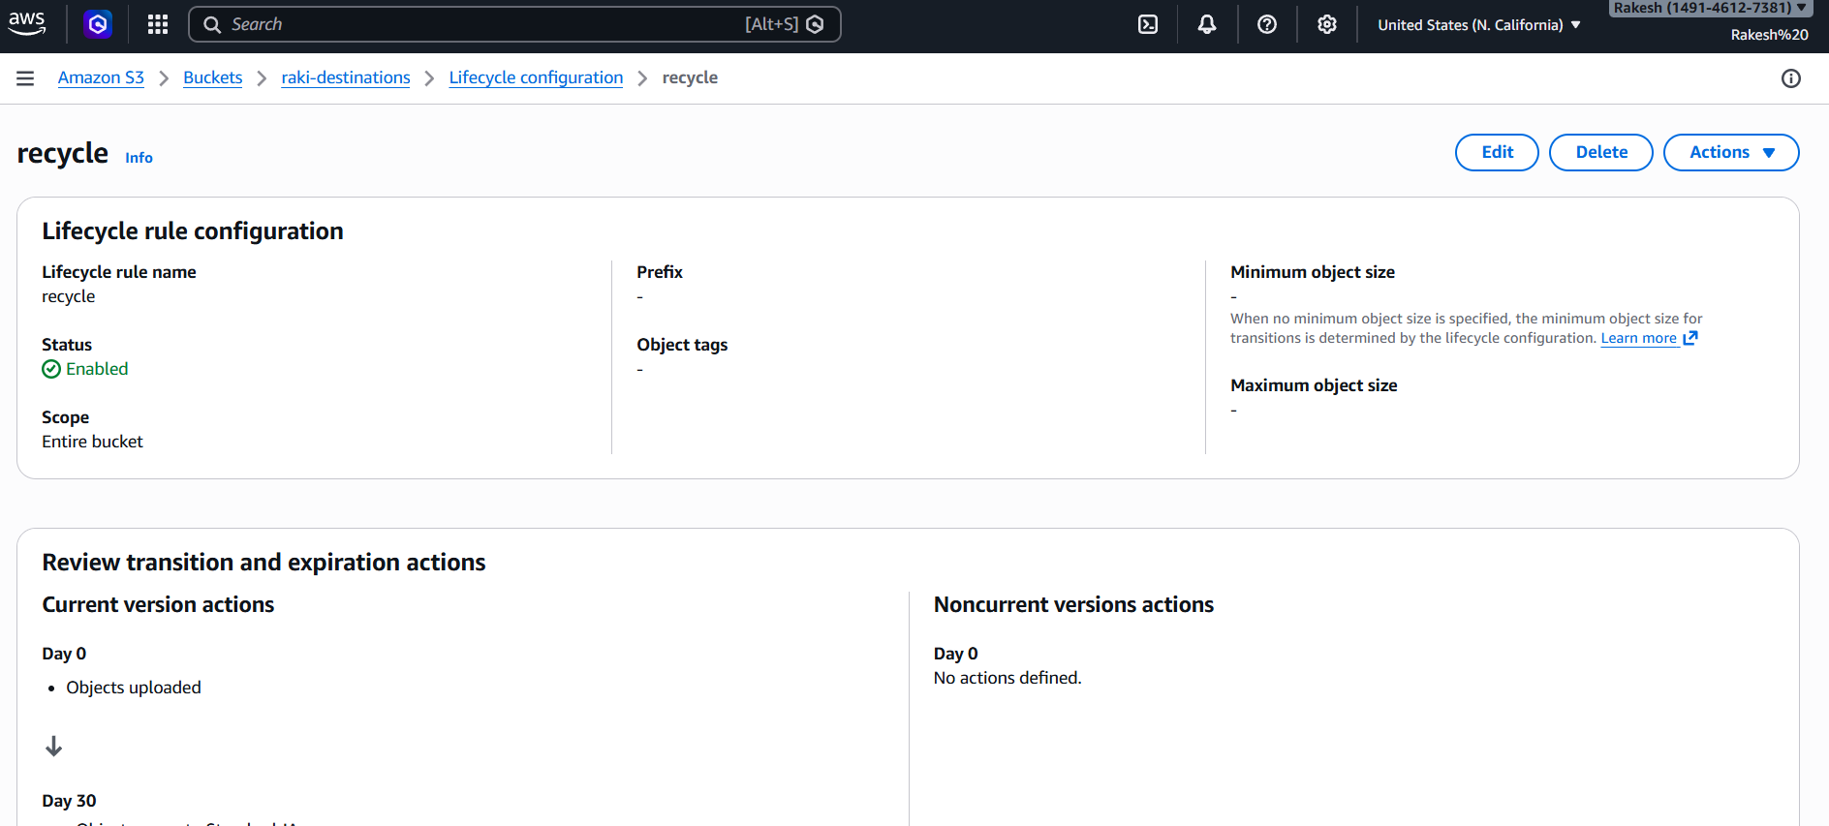
6. Push some objects to S3 using the AWS CLI.
First I have created a txt file with some content through CLI
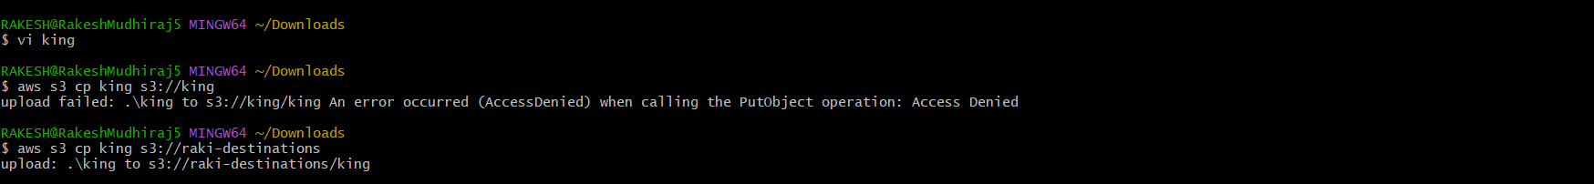
I have checked whether the file is uploaded or not.
It is uploaded successfully
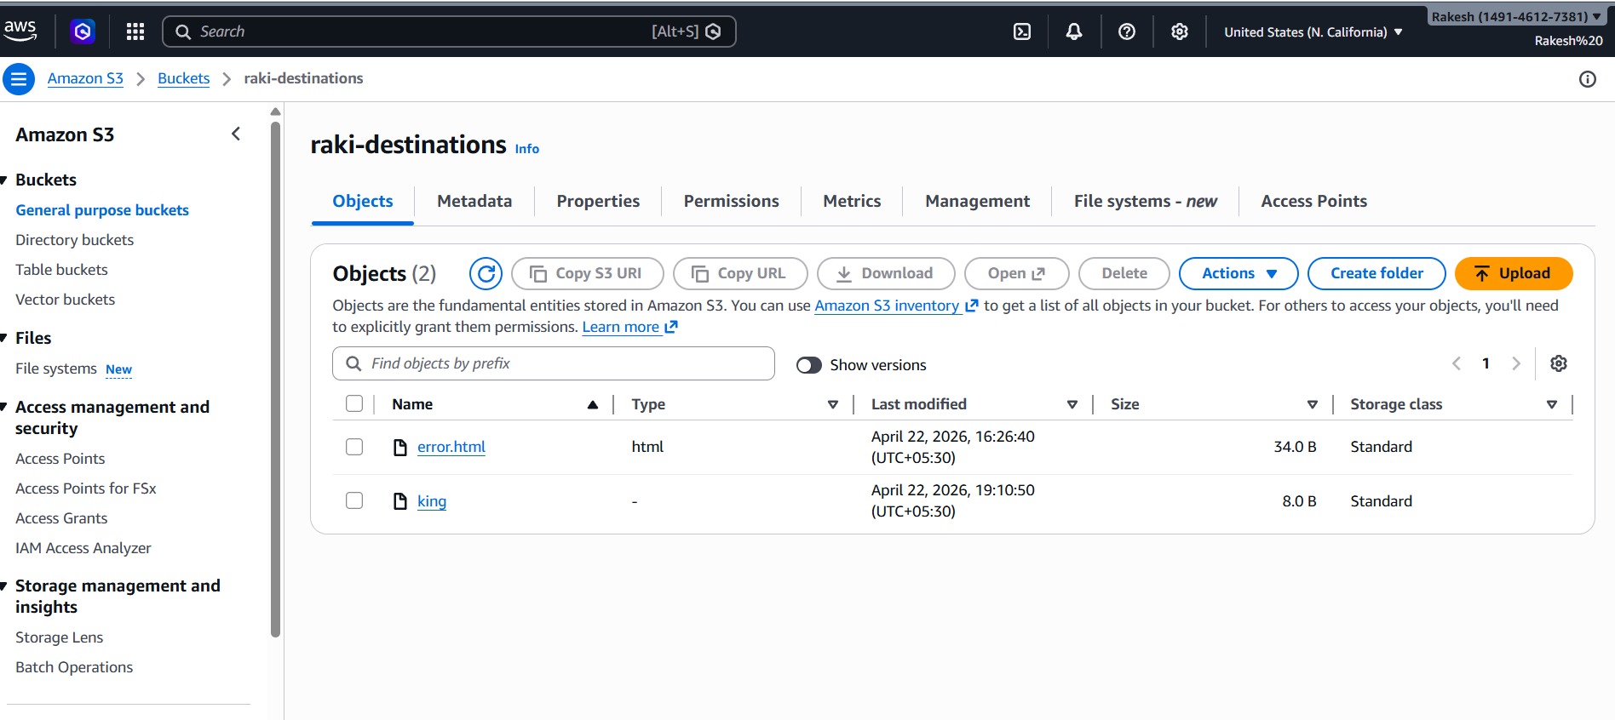
7)Write a Bash script to create an S3 bucket.
Wrote a bash script to create a bucket
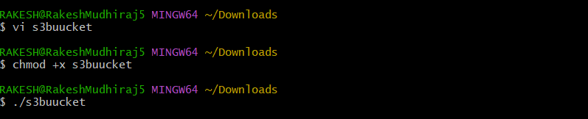

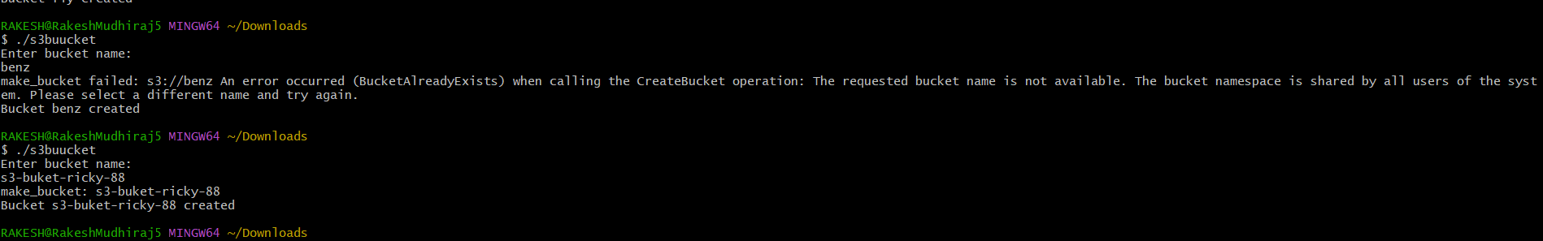
Verified whether the bucket is created or not.
Bucket created successfully
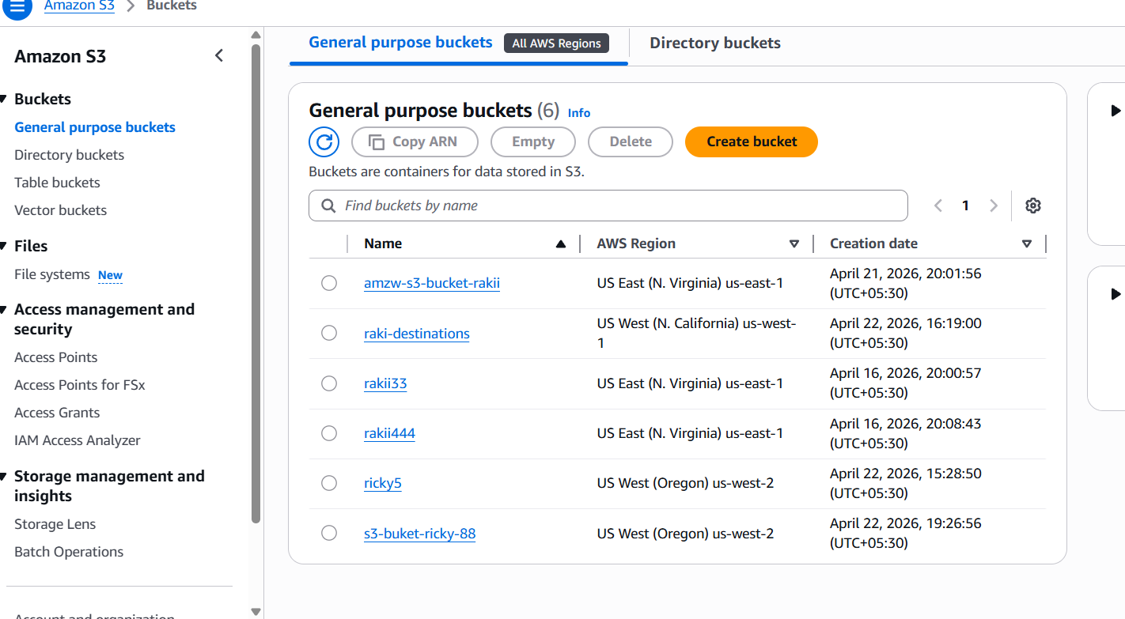
8) Upload a 1 GB file to S3 using the CLI.
Create a 1 GB Test File:-
dd if=/dev/zero of=bigfile.bin bs=1M count=1024
To upload the file to s3:-
aws s3 cp bigfile.bin s3://shaso6x-bucket/

